CORPORATE RESPONSIBILTY
Social and environmental responsibility is an essential aspect of the fashion and textile supply chain. At Netraco, Corporate Responsibility is at the heart of our business practices as we strive to continually improve our supply chain. Social and environmental compliance is something we care deeply for.
Our long-term mission is to contribute to structural improvements in the fashion value chain. Netraco fully supports the sustainability goals of the brands and retailers that work with us. We endeavour to fulfil their requirements, thereby contributing to collectively reducing our environmental footprint and at the same time positively impacting the social circumstances of workers’ lives.
An effective CR-policy is crucial in today’s fashion and textile industry. We as a private label company in fashion acknowledge that we have our responsibilities towards our suppliers, its workers, communities and the environment.
We partner up with production facilities in the Global South who have a vested interest in improving their own social and environmental standards. Our CR team at our HQ office in Amsterdam closely follows European and global developments in sustainability standards and guidelines. Netraco ensures best practise in an effort to comply with current and future global industry standards.
Netraco has invested in building a CR team, which comprises a Corporate Responsibility Manager in the Amsterdam office and a CR team and specialised Quality Assurance team which function from our Shanghai office. Working closely together, both offices ensure that Netraco products are produced in approved compliant factories, which the Netraco team checks regularly. Additionally, finished products go through a rigorous quality control check before delivering it to our customers.

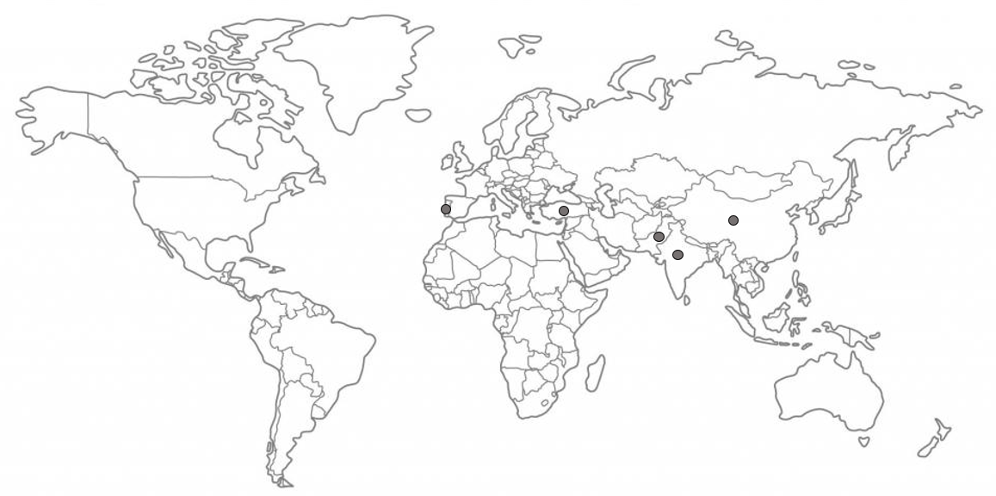
PRODUCTION LOCATIONS
Our supply chain partners are located in Pakistan, China, Turkey, India and Portugal. By sourcing from different countries, different risks are involved. Companies are required to identify, prevent and mitigate risks in their supply chain, manufacturing process and export chain. Our CR team analyses which risks occur in which countries and sectors (leather and textile), and this way tries to limit these risks by means of performing constant due diligence. We have developed an extensive risk document in which all the possible risks in our supply chain are highlighted. In choosing the right production locations, we always take into account such risks and also conduct an open dialogue with our suppliers to ensure that severe risks do not occur during Netraco production, nor in the factory in general. As we have long term relationships with our suppliers, we assist our supply chain partners where necessary in improving the production process and eliminating possible risks.

CHOOSING OUR BUSINESS PARTNERS
Before choosing the factory for production, we check which factory meets the customer's requirements. We monitor the customer's social and environmental requirements, and on this basis we select the factory. We also take into account what kind of product the customer is looking for, as our factories are specialized in various things. With regard to Corporate Responsibility, this means that a social compliance check is requested from the factory before the order process starts. When a factory is chosen for production, we, together with the factory, go over all information regarding social and environmental compliance to make sure all customers’ standards are clear and met. Corporate Responsibility is a continuous process for both factories and brands, and only by working together can we strive for maximum compliance.
As we have direct and regular contact with our suppliers, and the relationships with our suppliers are long-term relationships developed over the years, transparency and communication is key. We aim for constructive dialogue with the factory teams and assist our supplier partners in reaching the required social and environmental standards. We only work with factories that have scored minimum a C on their BSCI audits. Next to BSCI audits, we also conduct internal Netraco audits carried out by our local CR representatives.

PERFORMANCE MEASUREMENT SYSTEMS

Amfori BSCI & Amfori BEPI
Netraco measures social and environmental compliance by means of auditing processes. Netraco is a member of the Business Social Compliance Initiative (BSCI), a global initiative that supports companies to improve labour conditions in their tier 1 factories. By being a BSCI member, Netraco acknowledges important official guidelines such as the Convention of the International Labour Organization (ILO) and the UN Universal Declaration of Human Rights (UDHR). We have developed our own Code of Conduct, which outlines the minimum social and environmental standards and requirements that our suppliers are expected to follow. Our Code of Conduct is based on the Conventions drawn by the UN’s International Labour Organisation and the UN’s Universal Declaration on Human Rights. We at Netraco aim to only work with suppliers that share our beliefs and values, and therefore expect that our suppliers are responsible ensuring our Code of Conduct is implemented at all times. However, we acknowledge that we as a fashion brand also have to meet and fulfil certain expectations and obligations towards our suppliers. That is why we have established That is why we are developing our Code of Conduct as a Two-Way Code of Conduct, in which we outline the responsibilities we have towards our suppliers and our supply chain. This Two-Way Code of Conduct will be implemented in the beginning of 2021.

The environmental branch of Amfori is called the Business Environmental Performance Initiative (BEPI). Netraco has joined BEPI in an effort to improve its supply chain beyond tier 1. The goal of BEPI is to manage and improve environmental progress and create supply chain visibility further down the chain. We encourage our suppliers to register on the BEPI platform. In 2021, Amfori BSCI and Amfori BEPI will converge into one platform: the Amfori Sustainability Platform. Using this platform, we can manage the sustainability performance, social and environmental, of our suppliers.

Fair Wear Foundation
Several brands Netraco works with are a member of the Fair Wear Foundation. The Fair Wear Foundation (FWF) is a multi-stakeholder initiative in which brands, factories and other organizations in the textile industry work together to improve working conditions in textile supply chains. FWF’s motto is continuous improvement and a pro-active attitude of the factory. When a brand requests a factory to cooperate with them on the basis of the FWF, the factory will receive information about the initiative and what is expected of the factory. As some of our customer brands are FWF-member, we have experience in working alongside FWF requirements and some of the factories we work with are FWF-audited.

Leather Working Group
Leather Working Group (LWG) is an international, not-for-profit membership organisation and responsible for the world’s largest leather sustainability program. LWG aims to improve the environmental impact of the leather industry by assessing and certifying leather manufacturers. As Netraco is specialized in leather, and we want to source for more sustainable solutions in our production chain, we are working towards LWG-certification with our suppliers. The LWG-process is a thorough three-step process in which leather manufacturers need to demonstrate their future sustainability ambitions. Within these steps, they are encouraged to first fill out a Self-Assessment Questionnaire, a kind of baseline measurement where they can determine where their greatest challenges lie and where improvements are most needed in order to protect the environment. After the Self-Assessment and the following steps are completed, the leather manufacturers will be audited and their score is determined based on the results of the audit. One of the tanneries we use is LWG-certified and has scored a Bronze Medal.

QUALITY ASSURANCE

Materials
We help our customers by advising them on specific styles, materials and production techniques based on their preferences and wishes. Every product and style is unique, and therefore needs to be assessed individually. In doing so, we always consult our factories’ specialists as we value their opinion. If a customer wants to source more sustainable materials, we always look for qualities that suit both the material and the customer's image. Our production and design team, together with our CR Manager, will make sure all customers’ wishes, regarding product and the production process, are met.

Product/Material testing
All products (textile and non-textile) that are imported or traded in Europe must comply to European Legislation on Environmental and Chemical Compliance. Brands or retailers can request a factory to test on chemical (and/or physical) compliance before a product goes into production, mainly to detect any chemical non-compliances with the fabric before the start of production of large quantities.

Chemicals and restricted substances
Chemicals are commonly used in the textile and apparel industry. In order to make sure the chemicals used are not harmful for the environment and the people that come in contact with it, the use of chemicals can be tested. Regarding chemical testing, we have developed our own Restricted Substances List (RSL), in which we outline the chemicals that may (within certain limits) be used and which are forbidden. The Netraco RSL includes global legal requirements for textile products (such as REACH, EC or POP), additional requirements based on best practice as identified by Eco label organisations such as Greenpeace and the requirements of our main customers. These regulations encompass registered chemicals that up to a specific level (limit) are not allowed to be found in a final product that is put on the market. Our customers can request chemical testing conducted by international accredited testing labs based on their own RSL/our RSL, or can determine on which chemicals they would like their products to be tested in order to monitor whether they comply.
For leather products we advise a Chrome VI aging test on a piece of the hide. The Chrome VI aging test can be done at an accredited testing agency. Products that contain levels of Chrome VI will not be marketed and Netraco forbids the presence of Chrome VI in its products.

Water & sludge testing
A hot topic that is becoming increasingly relevant is water & sludge testing at wet processing facilities. Tanneries and dye houses are two examples of wet processing facilities. This industry is said to be a major cause of environmental pollution. In order to monitor the substances used in the wet processing facilities, water and sludge testing can be done. To conduct water & sludge testing, a testing company will take samples of the water and sludge being discharged from the factory. The samples are tested on hazardous chemicals. The list of chemicals and limits that is used for conducting the water and sludge testing is called a Manufacturing Restricted Substances List (MRSL). Most brands make use of an RSL and an MRSL. Netraco expects its suppliers to take all the necessary measures to avoid environmental degradation. Our supplier partners must commit to meet the legal (local and national) quality levels of discharged water, meaning waste water must be treated before discharging. Netraco encourages its suppliers to use the Waste Water guidelines of ZDHC.

ANIMAL WELFARE
At Netraco we are committed to make sure that all our products are made with respect for people, the environment and animals. Therefore we expect all our supply chain partners to follow our animal welfare policy. All the leather that is used in our garments is a by-product from the meat industry. We don’t use any leather from exotic, threatened or endangered animals. We do not use real fur and no animals should be harmed in the production of our products. Netraco is committed to the five freedoms for animals set by the Farm Animal Welfare Council and the Farm Animal Welfare Committee;

- Freedom from hunger or thirst by ready access to fresh water and a diet to maintain full health and vigour.
- Freedom from discomfort by providing an appropriate environment including shelter and a comfortable resting area.
- Freedom from pain, injury or disease by prevention or rapid diagnosis and treatment.
- Freedom to express (most) normal behaviour by providing sufficient space, proper facilities and company of the animal's own kind.
- Freedom from fear and distress by ensuring conditions and treatment which avoid mental suffering.

